Elle Steele, Rhona Knox & Tina GoldSmith

AKCH

January 2025

**NOVEMBER**

**2024**

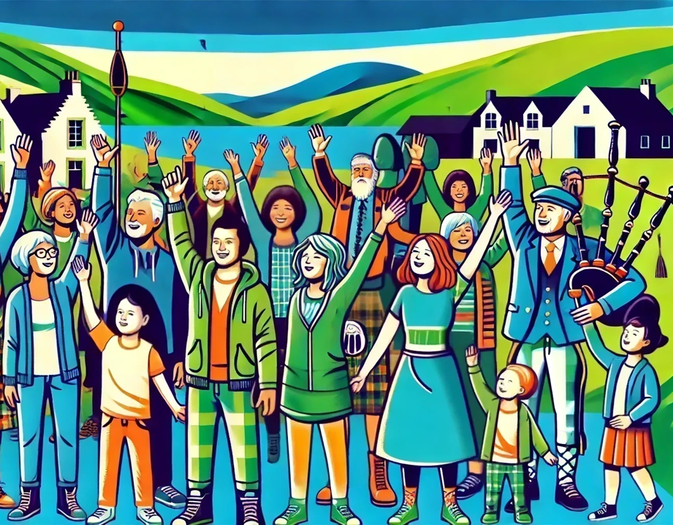

Avich & Kilchrenan CAP Survey Report

Part One: All of the Area

**Introduction**

During November 2024, AKCH and DIG conducted a survey to understand the needs, ideas and thoughts of our community, in terms of how we want to make our wonderful area even better in the next 5yrs.

These responses will form the foundation of Community Action Plans and potentially a Local Place Plan.

109 people completed the survey; 40 Kilchrenan, 46 Dalavich, 3 Inverinan and 20 other. Respondents gender, age, employment/retirement and time of residence reflect well the broader community.

**Table of Content: Page**

1. **Overall Likes & Dislikes of The Area – based on comments from respondents 2**
2. **Community Spirit, Communication & Events 2-3**
3. **Improvement Priorities:**
4. **Overall Priorities – based on comments from respondent 4**
5. **Responses to Specific Topics – closed and open question responses**

* **Tourism 5-8**
* **Employment & Training 9-11**
* **Affordable Housing 12-13**
* **Transport 14**
* **Heritage and Environment 15-18**
* **Recreation by Age Group 19-22**
* **Health & Wellness 23-24**
* **Community Resilience 25**

1. **Responses to Potential Projects:**

* **EV Chargers 26**
* **Sports Hub 26**
* **Forestry School & Academy 26**
* **Forestry Shed 27**
* **Kilchrenan School 27**
* **Dalavich & Kickrenan Kirks 28**

1. **Who Completed the survey? Non identified demographics of respondents 20**
2. **Link to e-copy of report PLUS all comments made the survey 29**
3. **Overall Likes and Dislikes About Our Area** – open-ended comments
4. **Community Spirit, Communication & Events :**

|  |  |
| --- | --- |
|  |  |
|  | |

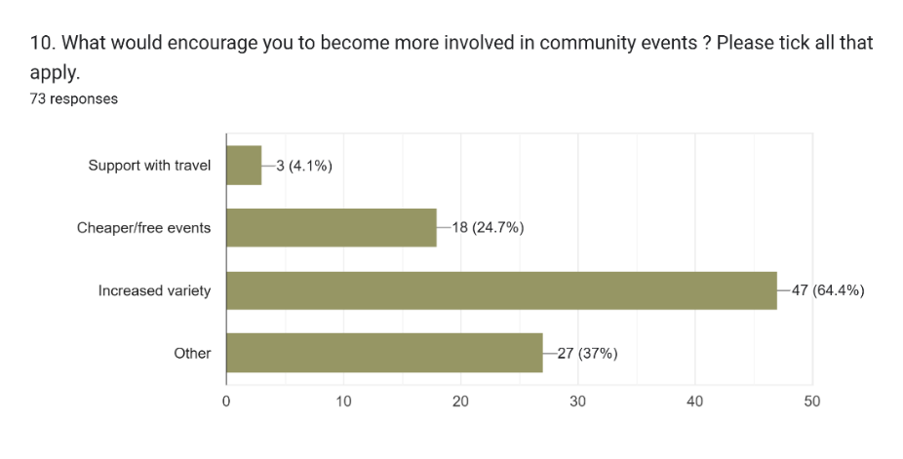

**Open Responses:**

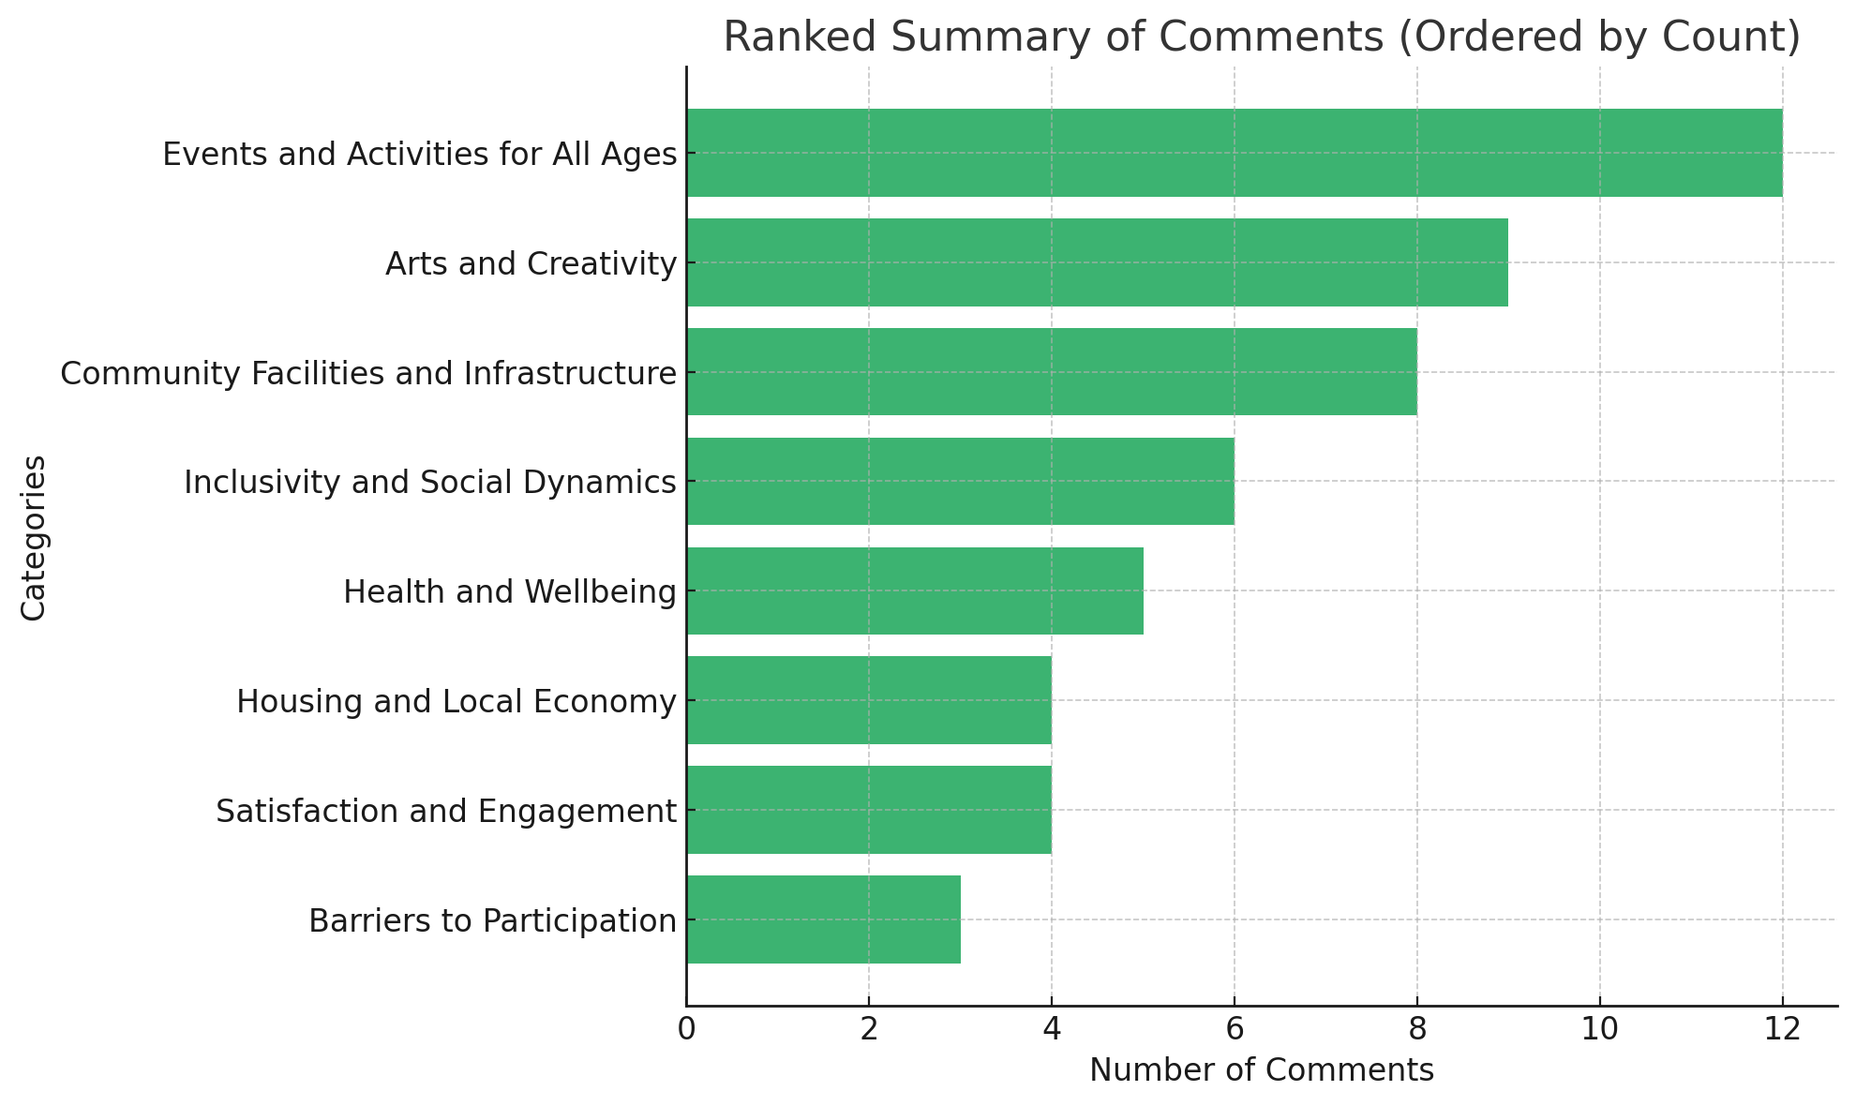

**1. Events and Activities for All Ages (Comment Count: 12):** Diverse events such as talks, demonstrations, mobile cinema, and walking groups; Activities for children, young people, and under-30s beyond the existing Christmas party; Seasonal and wildlife-focused events, e.g., stargazing and conservation campaigns; Recreational training like kayaking, archery, and sports weekends.

**2. Arts and Creativity (Comment Count: 9):** Creative workshops: painting, sewing, knitting, poetry, creative writing, and pottery; Book clubs, choirs, and gardening events focused on sustainability and climate change.

Film nights and food-related events like cooking classes or food fairs.

**3. Community Facilities and Infrastructure (Comment Count: 8):** Requests for a cosy corner in the hall with comfortable furniture for small group gatherings; Air filtration in community spaces to reduce the spread of illnesses; Improved communication and openness in village hall activities; inspired by neighboring communities; Suggestion for a Cabin Owner’s Committee for better engagement.

**4. Inclusivity and Social Dynamics (Comment Count: 6):** Need for events to draw the community together and reduce interpersonal conflicts; Wider community involvement, including outlying residents; Variety in event timings to accommodate both working and retired residents.

**5. Health and Wellbeing (Comment Count: 5):** Wellness-focused events like yoga, sound baths, and outreach from health organizations.; Support for aging populations through health-related and mind-stimulating activities.

**6. Housing and Local Economy (Comment Count: 4):** Demand for affordable housing for locals and workers in the area; Efforts to attract more visitors and boost the local economy.

**8. Satisfaction and Engagement (Comment Count: 4):** General satisfaction with current offerings, but suggestions for more wellness or fitness classes.; Occasional participation in existing events but less frequent engagement overall.

**7. Barriers to Participation (Comment Count: 3):** Limited time due to shift work or personal commitments; Infrequent attendance due to narrow interests.

1. **Improvement Priorities:**
2. **Summary of open-ended questions:** comment count from Q28c (What would be your top priority for local improvement?), Q28d (What do you think would improve life for most people?) & Q63 (Is there anything else you would like to add or comment upon which could help us identify local priorities?)

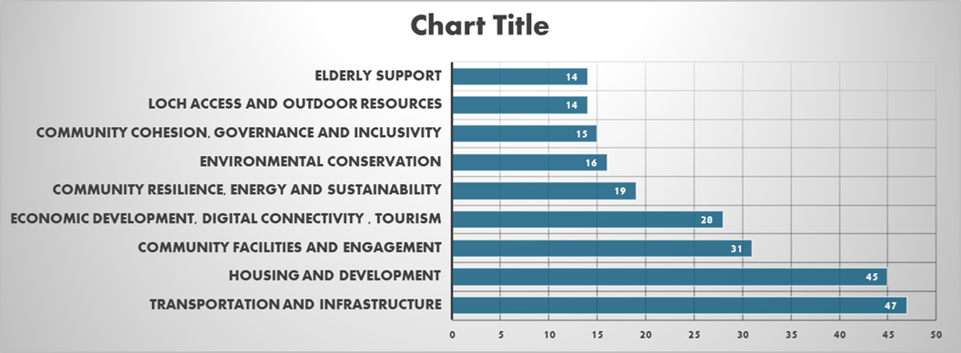

**Key Focus in Each Theme**

**1. Transportation & Infrastructure:**

Better public transport, road safety (speed limits, potholes), road repairs (back road), improved logistics for goods, innovative transport solutions, access to essential services

**2. Housing & Development**

Affordable housing, adaptive reuse of existing buildings, long-term rentals for locals, housing for key workers, addressing barriers to local living, land for sustainable living

**3. Community Facilities and Engagement**

Increased utilization of halls, hosting more events for all demographics, friendly play areas, more shop and eating out options.

**4. Economic Development, Digital Connectivity & Tourism**

Sustainable tourism, reinvestment in the community, encouraging/supporting local business growth, fibre broadband connection to support local work, education, and businesses, rewilding projects, promoting tourism through Visit Scotland and social media, enhancing tourist facilities (café, toilets, rest stops).

**5. Community Resilience, Energy & Sustainability**

Preparing for climate disruptions/extreme weather, emergency preparedness, emergency communication infrastructure, sustainable energy projects (promoting microhydro systems, reducing red tape for renewable projects), providing discounted/free energy to locals

**6. Environmental Conservation**

Preserving and restoring natural habitats, preserving landscapes, better waste management, managing forests, litter-picking, balancing development with conservation.

**7. Community Cohesion, Governance & Inclusivity**

Transparency in decision-making, better communication, inclusive governance, conflict resolution

**8. Loch Access & Outdoor Resources**

Community loch access (Kilchrenan) for recreation, conservation, and tourism development, expanding loch facilities for kayaking, canoeing, houseboats, cycling, and fishing

**9. Elderly Support**

Tailored support for the elderly, addressing digital literacy (for elderly and all), ensuring accessible resources, accessible transportation, linking care need with job creation

**b) Responses to specific improvement topics – closed and open questions**

**TOURISM**

|  |  |
| --- | --- |
|  |  |

|  |  |
| --- | --- |
| **Forms response chart. Question title: 14. What new facilities would you like to see for residents and visitors? Please tick all that apply.. Number of responses: 100 responses.** |  |

**Open-ended Comment Regarding Facilities for Resident and Visitors**

**1. Improved Community Facilities and Amenities:** Multi-purpose community spaces for workshops, medical sessions, and events; Indoor facilities for fitness, football, and bad-weather activities; Affordable accommodation options (e.g., pods, bunkhouses, or hostels).

**2. Recreational and Outdoor Activities:** Loch access improvements (e.g., boat hire, jetties, recreational areas); Marked walking and cycling routes, including circular paths; Water sports facilities, sailing competitions, and trim trails.

**3. Support for Families and Children**: Better playgrounds and play areas for all ages; Clubs, workshops, and forest school programs; Addressing childcare and activity needs for local families.

**4. Enhanced Tourism Information and Infrastructure:** Clearer signposting and maps for walking and cycling routes; Wildlife and rainforest information displays, astronomy leaflets, and tourist maps; "What's On" information and event promotion.

**5. Better Roads and Accessibility:** Improved roads and parking spaces; Better signage and road use management; Designated areas for campervans.

**6. Environmental and Sustainability Initiatives:** Birdwatching hides, free emergency bothies, and EV charging points; Local initiatives such as a "Make and Mend Shed" for repairs and crafting.

**7. Economic and Council Support:** Increased council support for the community center and local economy.

Exclusive activities to differentiate from other villages.

**What attracts visitors to the area:**

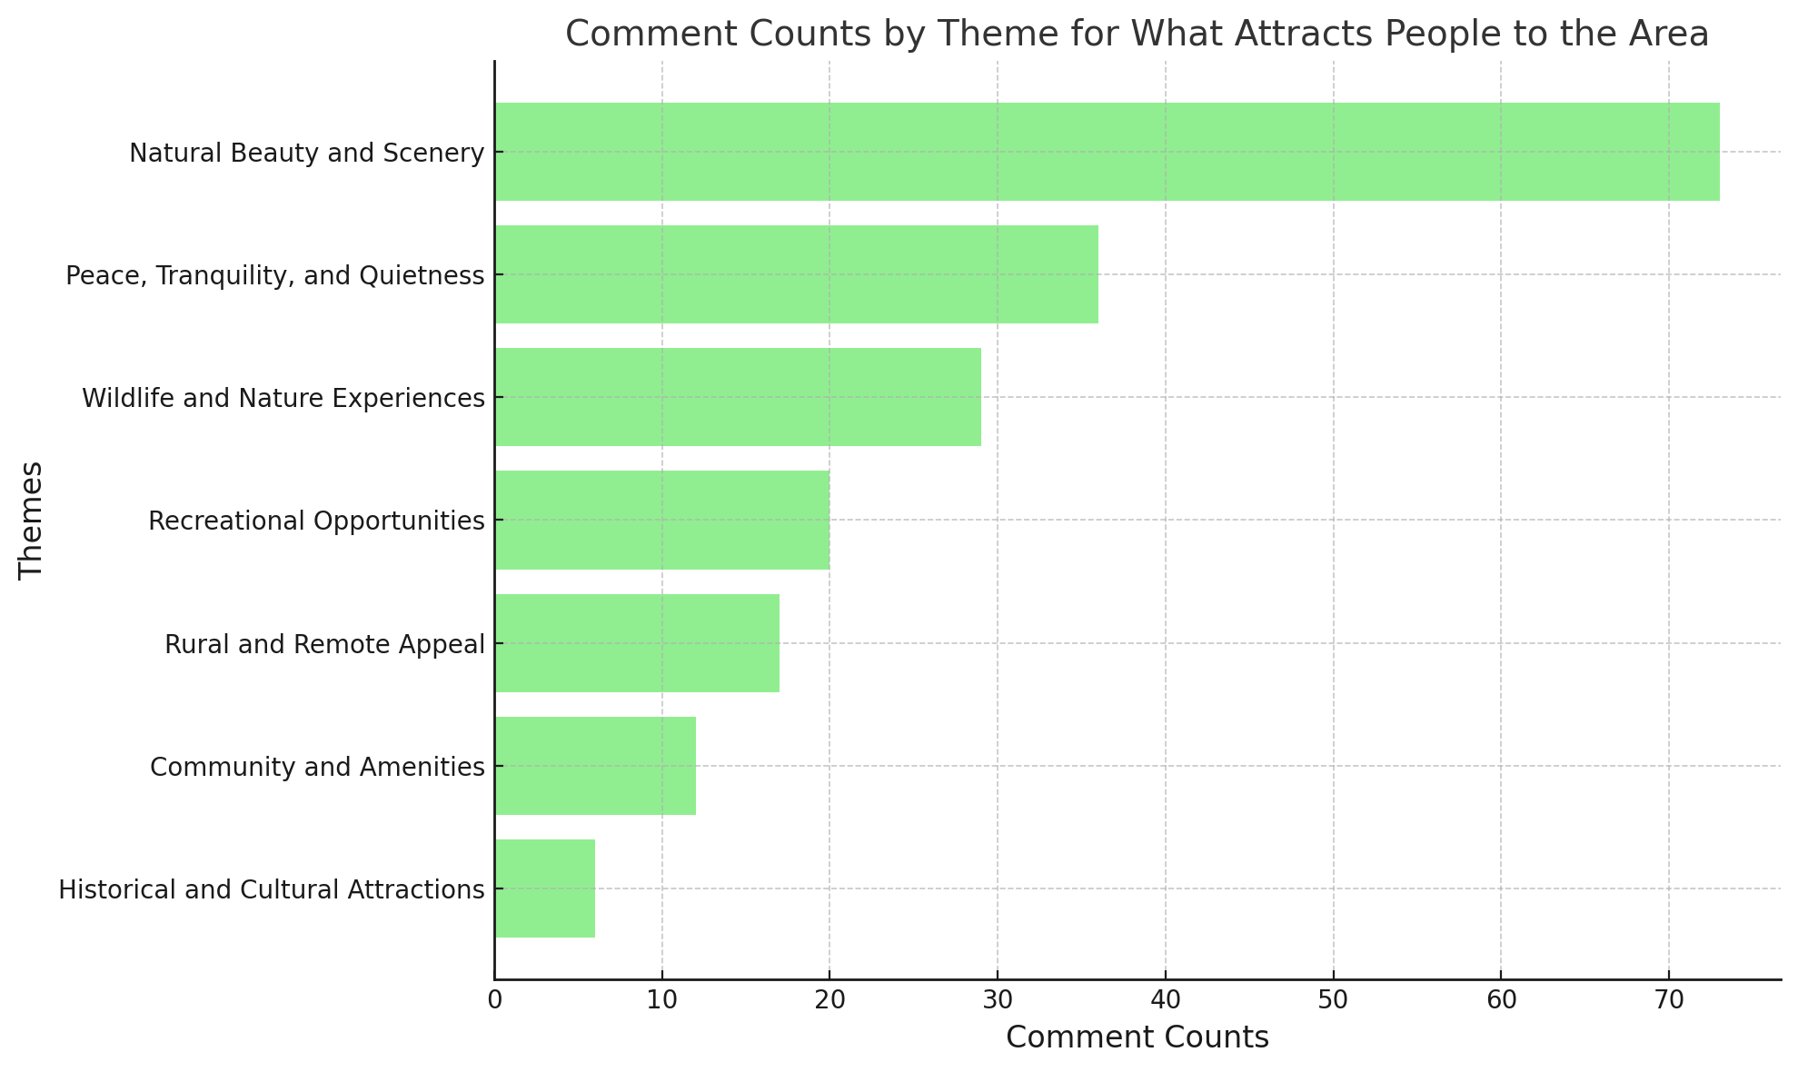

**1. Natural Beauty and Scenery**: Stunning landscapes, picturesque surroundings, scenic views; Lochs, mountains, waterfalls, and forests; Emphasis on unspoiled, tranquil beauty.

**2. Peace, Tranquillity, and Quietness:** Escape from the bustle of modern life; Solitude, relaxation, and a slower pace of life.

**3. Wildlife and Nature Experiences:** Diverse wildlife, flora, and fauna; Opportunities for outdoor activities like fishing, birdwatching, and exploring wild spaces.

**4. Recreational Opportunities:** Walking, cycling, kayaking, paddle boarding, and sailing.

Base for exploring nearby areas like Glencoe.

**5. Rural and Remote Appeal:** Remoteness and low population density; Appeal of rural living and physical isolation.

**6. Community and Amenities:** Social club, café, shop, and the friendly local community.

Welcoming environment for visitors and holidaymakers.

**7. Historical and Cultural Attractions:** Castles, churches, and local history; Opportunities to engage with the culture and heritage of the region.

**What discourages visitors from this area:**

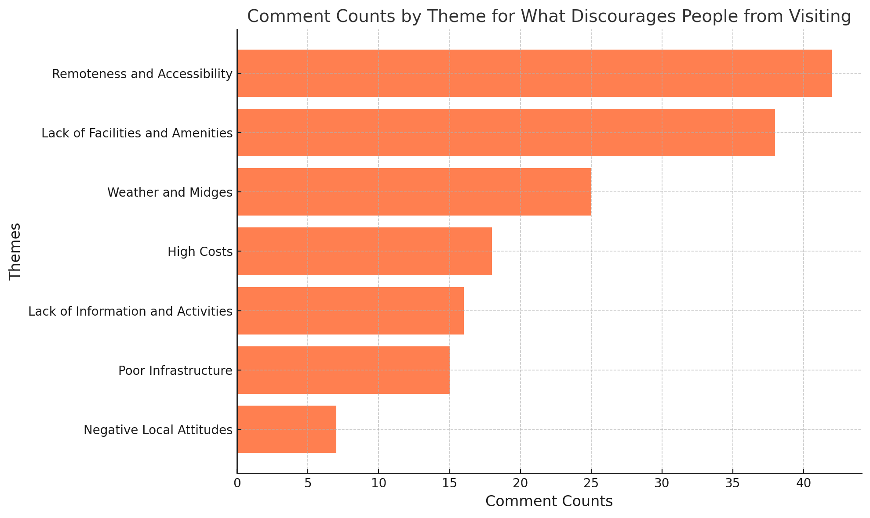

**1. Remoteness and Accessibility:** Distance from towns and amenities; Difficult single-track roads and long journey times; Limited public transport.

**2. Lack of Facilities and Amenities:** Few public toilets, cafes, or restaurants; Insufficient family or child-friendly activities; Limited affordable or lower-cost accommodation.

**3. Weather and Midges:** Wet weather, unpredictable conditions; High prevalence of midges during summer.

**4. High Costs:** Expensive accommodation and local goods; Comparatively high rental prices for cabins.

**5. Lack of Information and Activities:** Poor promotion of local attractions and things to do; Limited recreational opportunities, especially for families; Lack of advertising for unique features (e.g., dark skies, rainforest).

**6. Poor Infrastructure:** Poorly maintained roads and infrastructure; Limited or seasonal services (e.g., pub not open daily).

**7. Negative Local Attitudes:** Complaints about some locals being unwelcoming or rude; Perception of tourists as nuisances.

**Other Open-ended Comments About Visitors**

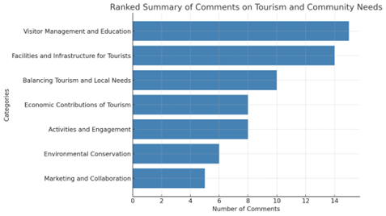

**1. Visitor Management and Education (Comment Count: 15):** Visitors should respect the natural beauty, Countryside code, and privacy of residents; Address issues with litter, road safety, and behaviour of tourists; Improve communication about community facilities, rules, and offerings (e.g., walking routes, bins, cycling safety); Encourage responsible tourism while preventing over-tourism and maintaining tranquillity.

**2. Facilities and Infrastructure for Tourists (Comment Count: 14):** Suggestions for more public waste disposal facilities, recycling bins, and rest stops; Better access to the loch, such as jetties, boat hire, and recreational facilities; Indoor activities and multi-purpose spaces for bad weather; Development of a library, gym, or community space with second-hand equipment.

**3. Balancing Tourism and Local Needs (Comment Count: 10):** Emphasis on sustainable tourism that does not overwhelm local resources or disrupt the community; Support for permanent residents with affordable housing and better integration with tourists; Focus on attracting quality, long-term visitors rather than large numbers.

**4. Economic Contributions of Tourism (Comment Count: 8):** Importance of visitors to the local economy, supporting cafes, restaurants, and other businesses; Potential for themed tourism (e.g., dark sky observations, crafting, historical interests) to attract niche visitors.

**5. Activities and Engagement (Comment Count: 8):** Calls for workshops, classes, and community-centered events like supper clubs or cultural evenings; Increased activities for children, such as clubs, workshops, and better playparks.

**6. Environmental Conservation (Comment Count: 6):** Concerns about damage caused by wild camping, fishing waste, and tree cutting; Need for information leaflets on local wildlife and temperate rainforests to encourage conservation-minded visitors.

**7. Marketing and Collaboration (Comment Count: 5):** Lack of centralized community marketing or collaboration among local businesses; Ideas for a Dalavich website or business owners' group to coordinate efforts.

**EMPLOYMENT & TRAINING**

|  |  |
| --- | --- |
|  | Forms response chart. Question title: 19. What sorts of employment opportunities should we develop? Please tick all that apply.. Number of responses: 103 responses. |

**Open-ended Comments: employment opportunities**

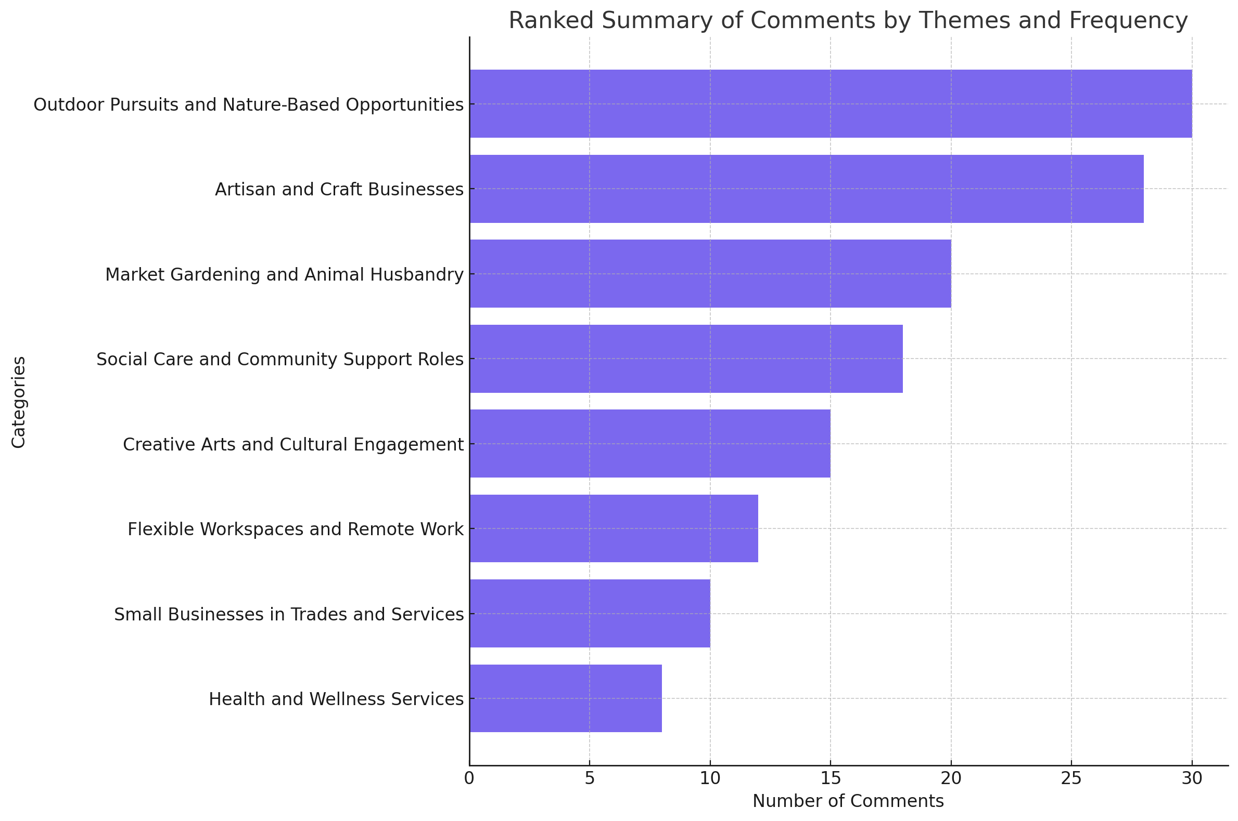

**1. Outdoor Pursuits and Nature-Based Opportunities (Comment Count: 30):** Strong emphasis on outdoor activities, including:Nature-focused pursuits, such as guided tours and adventure sports; Wildlife and conservation-related jobs like eco-tourism and stewardship.

**2. Artisan and Craft Businesses (Comment Count: 28):** Demand for locally focused industries like:Craftwork, woodworking, and artisanal food and beverages; Craft workshops for both locals and tourists.

**3. Market Gardening and Animal Husbandry (Comment Count: 20):** Suggestions for agricultural enterprises:Local food production, sustainable farming, and market gardening; Opportunities in animal husbandry, supporting rural livelihoods.

**4. Social Care and Community Support Roles (Comment Count: 18):** Highlighting the need for:Roles in social care to support an aging population; Community-driven initiatives to foster resilience.

**5. Creative Arts and Cultural Engagement (Comment Count: 15):** Proposals for creative roles like:Artists, musicians, and cultural facilitators; Events, workshops, and activities centered on the arts.

**6. Flexible Workspaces and Remote Work (Comment Count: 12):** Importance of shared office spaces and reliable internet for: Supporting remote workers and internet-based businesses; Creating communal spaces for collaboration and innovation.

**7. Small Businesses in Trades and Services (Comment Count: 10):** Opportunities for essential tradespeople: Builders, electricians, plumbers, and other skilled workers; Roles tailored to meet the community’s immediate needs.

**8. Health and Wellness Services (Comment Count: 8):** Interest in health and fitness-based businesses:Yoga retreats, wellness centers, and outdoor fitness programs.

**Open-ended Comments: barriers to new enterprises**

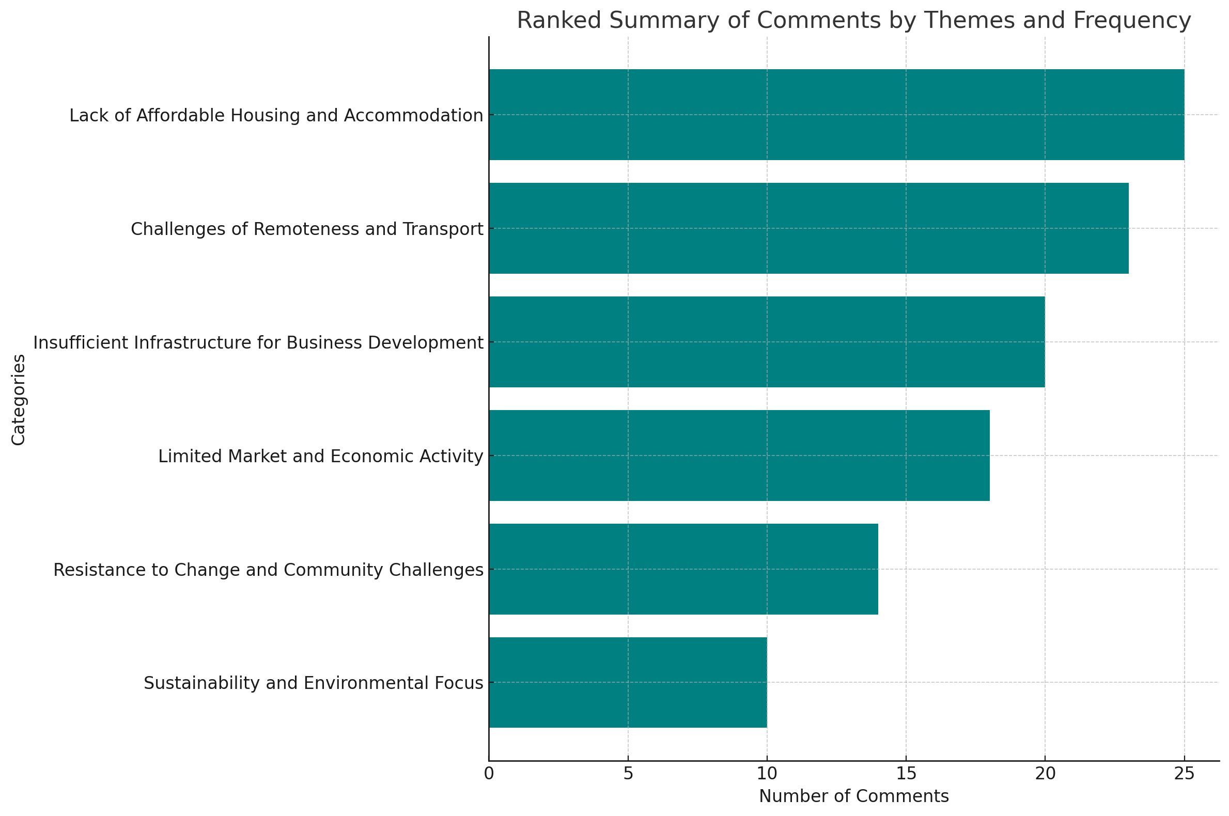

**1. Lack of Affordable Housing and Accommodation (Comment Count: 25) -** Limited affordable housing for residents and workers; Shortage of rental properties, causing difficulty in attracting and retaining population.**;** High housing costs driving people away or discouraging new businesses from settling.

**2. Challenges of Remoteness and Transport (Comment Count: 23) -** Remoteness as a barrier to economic growth and accessibility; Poor road conditions, lack of public transport, and high transportation costs.

Challenges in attracting workers and customers due to isolation.

**3. Insufficient Infrastructure for Business Development (Comment Count: 20):** Lack of commercial premises and shared business spaces for enterprises; Proposals for a business hub and flexible workspaces to boost local businesses; Limited access to reliable internet and mobile coverage hampering remote work and small enterprises.

**4. Limited Market and Economic Activity (Comment Count: 18):** Small customer base, especially outside of the tourist season; Over-reliance on seasonal tourism, with little scope for diversification; Need for initiatives to boost economic activity and attract visitors sustainably.

**5. Resistance to Change and Community Challenges (Comment Count: 14)**

Resistance to new enterprises and ideas from existing residents; Perception of competition and lack of collaboration within the community; Call for greater support and a more welcoming environment for new initiatives

.

**6. Sustainability and Environmental Focus (Comment Count: 10)-** Need for balancing tourism with conservation and sustainability; Support for rewilding and eco-tourism as viable economic opportunities.

**Open-ended Comments – education and training opportunities**

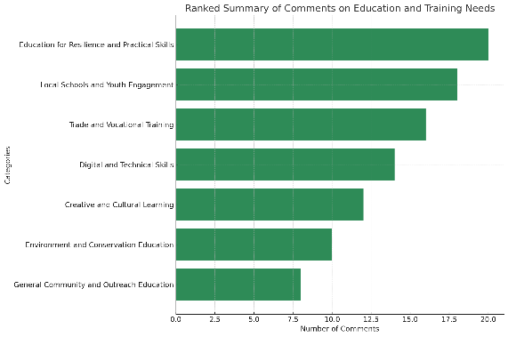

**1. Education for Resilience and Practical Skills (Comment Count: 20):** Training in sustainable living, life skills, and resilience, such as:Growing food, first aid, DIY maintenance, forestry, and gardening; Vocational training for young adults, including local industries like farming, forestry, and land management; Courses to support social care, elderly care, and fire safety.

**2. Local Schools and Youth Engagement (Comment Count: 18):** Reopening or repurposing schools to attract families and create opportunities for young people; Forest schools and outdoor education programs for children and youth; Sports clubs, nurseries, and activities to foster a sense of community among younger generations.

**3. Trade and Vocational Training (Comment Count: 16):** Apprenticeships and trade-based training in plumbing, carpentry, catering, and hospitality; Emphasis on linking courses to sustainable business opportunities; Collaboration with local colleges and organizations to provide accessible vocational training.

**4. Digital and Technical Skills (Comment Count: 14):** Training in IT, computer literacy, and safe online practices for older adults; Support for remote access further education and internet-based skills; IT-focused courses to facilitate working from home.

**5. Creative and Cultural Learning (Comment Count: 12):** Workshops on sewing, crafts, music, and creative arts; Heritage and cultural education for locals and visitors; Opportunities for artists, musicians, and writers to teach and inspire.

**6. Environment and Conservation Education (Comment Count: 10):** Programs on wildlife preservation, rewilding, and environmental stewardship; Bird watching and astronomy education to leverage local natural assets; Field trips and events to promote conservation awareness.

**7. General Community and Outreach Education (Comment Count: 8):** Community-focused courses, such as first aid and health training; Accessible learning spaces, like using the old church as an educational hub; Emphasis on promoting available opportunities through better outreach.

**AFFORDABLE HOUSING**

|  |  |
| --- | --- |
|  |  |
|  |  |

**Summary of Open Ended Comments (Sort of Housing / Community Purchase of Existing) :**

**1. Need for More Information and Practical Details (Comment Count: 25):** Concerns about understanding the financial and operational details of community-owned housing schemes.

Questions on funding, tenant criteria, management, and the long-term sustainability of such initiatives.

Desire for clarity on costs, community benefits, and potential liabilities.

**2. Importance of Balancing Housing Needs (Comment Count: 20):** Need to balance community-owned housing with private ownership to attract new residents and maintain property values; Emphasis on separating permanent housing from tourism-focused properties (e.g., short-term rentals); Importance of ensuring affordable housing for seasonal workers and long-term residents.

**3. Local Challenges and Concerns (Comment Count: 18):** Issues with zoning, lack of available development land, and delays in changes to local development plans; Problems with maintaining rental properties and meeting regulations; Criticism of existing practices, such as unused properties and the prevalence of Airbnb-style rentals.

**4. Support for Building New Homes (Comment Count: 15):** Advocacy for building new, well-insulated homes rather than repurposing existing housing stock; Focus on increasing housing supply to drive affordability and attract families.

**5. Community and Economic Growth (Comment Count: 12):** Recognition of affordable housing as critical to supporting broader community services and economic growth; Interest in integrating housing solutions with job opportunities, especially in tourism and hospitality.

**6. Preference for Community-Owned Housing (Comment Count: 10):** General support for community-owned housing schemes but with caveats about proper execution and long-term viability; Suggestions to purchase existing homes or cabins and convert them to community housing.

**7. Seasonal and Worker Housing (Comment Count: 8):** Need for rental accommodation specifically for seasonal workers and new residents contributing to the local economy.

|  |  |
| --- | --- |
| Forms response chart. Question title: 27. Would you support the building of new community owned social housing? . Number of responses: 101 responses. |  |

**Open Ended Comment of Community Building of New Housing:**

**1. Infrastructure and Feasibility Concerns (Comment Count: 20):** Limited land available for development and concerns about using grazing land; Insufficient sewage and water systems to support additional housing; Lack of public transport and road upgrades required for new developments; Questions about funding sources and management responsibilities.

**2. Preference for Thoughtful Development (Comment Count: 18):** Support for small-scale developments, such as: **c**lustered housing or individual homes integrated within the village; Avoiding large estates or developments that could disrupt the rural character of the area; Emphasis on green, low-impact architectural design to protect the environment.

**3. Affordable Housing as a Priority (Comment Count: 15):** Highlighted the need for affordable housing to attract families and workers; Recognized as a foundation for new businesses and community sustainability; Support for converting existing empty homes before building new ones.

**4. Community and Resident Impact (Comment Count: 12):** Concerns about ensuring housing benefits local workers and families rather than creating commuter housing; Preference for ensuring properties cannot become holiday homes or short-term rentals; Questions about the broader impact on the community, including services, schools, and job opportunities.

**5. Role of Housing Associations and Management (Comment Count: 10):** Advocacy for involving experienced housing associations to manage and maintain properties; Skepticism about community groups like DIG managing housing effectively; Emphasis on professional management to ensure long-term success.

**6. Environmental and Ecosystem Protection (Comment Count: 8):** Importance of preserving mature trees

and ecosystems during development; Calls for sustainable building practices and minimal environmental disruption.

**7. Questions About Demand and Future Use (Comment Count: 5):** Uncertainty about whether there is sufficient demand for new housing; Concerns about the long-term use and occupancy of the housing.

**TRANSORT**

|  |  |
| --- | --- |
|  |  |

### **Summary of Open-Ended Responses**

**1. Improved Public Transport Services – 50 Comments:** Suggestions for more frequent and reliable bus services; Requests for services tailored to non-drivers, the elderly, and schoolchildren; Ideas for community-owned or shared transport, such as minibuses for shopping and medical trips.

**2. Infrastructure and Amenities – 18 Comments:** Calls for better roads, weather-protected bus stops, and improved facilities; Proposals for enhanced access to community centers and outdoor activities; Interest in small-scale, viable transport options like mini-vans.

**3. Integration with Train and Bus Timetables – 20 Comments:** Advocated for bus schedules to align with train times to Oban, Glasgow, and Edinburgh; Focus on enabling convenient round trips for shopping and social needs.

**4. Alternative Transport Solutions – 15 Comments:**  Suggestions for car-sharing schemes and on-demand community transport; Proposals for social car services to reduce isolation among the elderly and young.

**5. Tourism and Local Economy – 12 Comments:** Emphasis on transport improvements to attract tourists and support local businesses; Calls for better integration of transport to align with tourism-related activities.

**6. Barriers and Concerns – 8 Comments:** Concerns about the financial feasibility of expanding services.

Skepticism regarding whether increased transport options would see sufficient usage.

**7. Positive Feedback – 2 Comments:** Some satisfaction with the current bus services, though acknowledgment of room for improvement.

**HERITAGE & ENVIRONMENT**

What would you like to see happening to improve and protect the **local environment**?

|  |  |  |
| --- | --- | --- |
|  |  | |
| **1. Environmental Management and Forestry:** Promote mixed/native forestry while reducing Sitka planting and dense commercial forestry; Replant cleared forest with native trees and restore habitats, including natural rewilding and habitat corridors; Continue tree management along shorelines and improve forest access responsibly.  **2. Community Engagement and Education:** Encourage community-led conservation projects, rewilding initiatives, and tidy-up events; Provide environmental education, including forest schools and wildlife gardening; Foster a sense of belonging by involving residents and visitors in environmental stewardship.  **3. Visitor Management:** Improve engagement with visitors, particularly wild campers, to minimize environmental impact; Enhance facilities such as public toilets, bins, and signage for better visitor behavior; Introduce designated areas for activities like fishing and water sports to protect vulnerable areas.  **4. Renewable Energy and Development Control:** Restrict wind farm developments and monitor their environmental impact; Ensure proper oversight of renewable projects to avoid harm to the environment; Limit other industrial developments like fish farming and quarrying.  **5. Litter Management and Prevention:** Install more rubbish, recycling, and dog waste bins in key areas; Use clear signage and launch awareness campaigns to discourage littering; Organize community-led litter picks and tidy-up events; Leverage funds like the Tourist Levy for maintaining litter management infrastructure; Consider technology like webcams for monitoring and deterring littering in hotspots.  **6. Wildlife Protection:** Prevent wildlife poisoning and control stray dogs to reduce disturbances; Regularly clear invasive species like rhododendrons and Sitka seedlings; Create and maintain nature corridors to support biodiversity.  **7. Accessibility and Infrastructure Improvements:** Enhance trails, signage, and public transport links to promote accessibility; Address local visual pollution, such as abandoned traffic cones or signposts; Improve neglected areas like community centers.  **8. Local Government and Policy Suggestions:** Strengthen local oversight on development projects with community input; Fund environmental management through policies like a Tourist/Visitor Levy; Improve waste management and recycling processes.  **9. Miscellaneous Suggestions:** Promote personal responsibility for maintaining property and local spaces; Provide guidance to visitors on respecting farmland and local areas during activities like calving and lambing. Limit mass tourism and restrict visitor numbers to protect the environment. | | |

|  |
| --- |
| **What would you like to see happening to protect and preserve local heritage?**    **1. Increasing Awareness and Education:** Provide better information on local heritage for locals and visitors through signage, guides, websites, or social clubs; Organize educational walks, talks, and workshops to teach about local heritage; Record oral histories, including stories from older generations and long-term residents; Create videos, blogs, and archives to share local heritage more effectively; Establish a museum or heritage center as a hub for learning and historical materials.  **2. Preserving Historic Sites and Buildings:** Preserve and maintain churches, schools, graveyards, and other historic buildings; Explore community ownership of churches for use as heritage centers or quiet workspaces; Learn from other areas to protect heritage sites effectively and ensure their long-term preservation.  **3. Community Involvement in Heritage:** Promote heritage workshops to teach old crafts, skills, and tourism-related trades; Foster community participation in heritage projects through research, events, and conservation programs; Highlight the link between heritage and a sense of place to encourage residents' connection to their environment.  **4. Improving Accessibility to Heritage:** Open heritage walks with informative signage and better access for locals and visitors; Maintain footpaths and trails, using potential funding like the Tourist/Visitor Levy; Improve village infrastructure, such as community centers, for heritage-related activities.  **5. Research and Management of Heritage**: Conduct more research to fully understand the extent of local heritage; Develop a management plan with professional oversight for preserving and promoting heritage; Create a dedicated, funded local body to manage heritage conservation and education.  **6. Tourism and Visitor Engagement:** Develop interest in local heritage to make sites appealing to visitors; Use humor or creative approaches to encourage good behavior from visitors while promoting heritage.  Highlight heritage as a tool to boost tourism and income for the local area.  **Key Themes for Improving Access of the Nature and Outdoors**    **1. Improved Walking and Cycling Infrastructure:** Develop better-marked walking and cycling paths with maps and signage; Create trails of varying lengths and difficulties (including disabled-friendly paths).  Install defined, well-maintained footpaths to replace narrow or unsafe roadside paths; Enhance pathways connecting key areas, such as from villages to community gardens and local forests.  Promote safety by adding markers or color-coded signs (e.g., green, red, black paths).  **2. Access to the Loch and Water Activities:** Increase loch access for swimming, canoeing, kayaking, or paddleboarding; Add facilities like jetties, boat rentals, or boat tours; Maintain and clean up existing loch-side areas, such as removing debris and glass; Create buoyed-off zones for beginner water sports and safer recreational use.  **3. Better Information and Education:** Provide maps, leaflets, and information boards to educate tourists and locals about nature and trails; Use signage for both directions and education (e.g., wildlife information, viewpoints); Organize guided walks, themed walks, and outdoor educational activities.  Emphasize public awareness of preserving nature through education programs in schools and communities.  **4. Maintenance and Partnerships:** Repair and maintain existing trails, footpaths, and forest walks.  Partner with forestry services (e.g., Forestry and Land Scotland) to ensure trails remain open and accessible: Encourage community involvement in managing and maintaining trails and access routes.  **5. Facilities for Visitors and Locals:** Build better car parking facilities near trails and access points to avoid village congestion; Add sheltered seating areas, bins, and rest stops; Develop an outdoor hub building for activities and information.  **6. Low-Impact Development:** Consider low-cost, off-grid hutting developments to allow access to nature while preserving the environment; Use gravel or stone pathways instead of tarmac to prevent damage to delicate areas.  **7. Miscellaneous Suggestions:** Encourage electric bike rentals, especially with options for families (e.g., Dutch bikes); Offer nature hides, athletic activities for children, and outdoor center initiatives.  Create outdoor activity spaces such as themed trails or areas for guided nature experiences.  **Key Themes for Improving Awareness to Heritage and Environment**    **1. Heritage and Visitor Centers:** Establish a heritage center or visitor center with tearooms, exhibits, and information; Use these spaces for guided walks, workshops, and exhibitions; Host permanent or rotating exhibitions in key locations like churches or community centers.  **2. Signage and Information Boards:** Create aesthetically pleasing, well-placed signs with historical and environmental information. Place information boards along paths, trails, and village areas to educate visitors and locals. Use signage to highlight local beauty spots, walking routes, and fragile ecosystems.  **3. Education and Community Engagement:** Develop educational programs for all ages, including schools, nurseries, and colleges; Offer workshops, awareness days, and events like bushcraft, foraging, and conservation activities; Encourage local talks, community meetings, and collaboration with experts.  **4. Digital and Print Resources:** Build a professional website with comprehensive resources like videos, maps, and blogs; Publish local walking routes, leaflets, and newsletters.; Use social media and email campaigns to share information and updates with locals and visitors.  **5. Improved Trails and Access:** Publish and promote waymarked walking routes to help people explore without harming the environment.; Ensure paths are well-marked for accessibility and safety.; Encourage responsible use of paths to reduce disturbance to wildlife.  **6. Activities and Events:** Host guided walks, nature trails, and interactive workshops; Develop group activities such as wildlife clubs or community events around heritage and the environment; Create themed events tied to the local history and natural environment.  **7. Partnerships and Collaboration:** Work with organizations like Kilmartin Museum or environmental groups to raise awareness**.** Engage heritage and environmental enthusiasts to research and promote the area. |

**RECREATION BY AGE GROUP**

**AGE 0-12yrs**

|  |  |
| --- | --- |
| **Adequate Facilities By Age Group** | **What’s Missing – open comments by comment count** |
| **Age 0-12yrs – 103 responses** |  |
| 1. **Play Areas and Playgrounds**: Lack of playparks, poorly maintained equipment, and the need for modern and diverse facilities for different age groups. Specific suggestions: adventure playgrounds, outdoor play areas, soft-play facilities, picnic benches, and repair/maintenance of existing play areas.  **2. Clubs, Activities and Social Opportunities :** Regular clubs, toddler groups, after-school clubs, holiday workshops, and structured social activities for children. Suggestions: sports teams, music/craft sessions, children's films/discos, and PVG-supervised events; Ideas for sports facilities such as football pitches, cycle paths, skateboard parks, and general outdoor recreation; Ideas for more nature/outward-bound opportunities for children including access to Loch Awe.  **3. Education & Child Care :** Suggestions for forest/outdoor schools, homeschooling support, and an education facility (e.g., similar to the Crannog on Loch Tay); Mention of the long bus journeys for children due to the lack of local education facilities; absence of nurseries, creches, or daycare options in the village; Families have to travel long distances for childcare service; Suggestions for introducing local daycare, toddler groups, or kindergartens.  **4. Community Engagement and Support:** Meeting spaces for young parents, parent-led clubs, or facilities for toddlers and young mums.  **5. Indoor Facilities and Activities:** more village hall sessions for kids; kids club with films, music, discos, crafts; day time activities in the village hall.  **6. General Observations:** "everything is missing" or there are very few facilities for children and families in the area; concerns about families traveling long distances to access activities in neighboring villages, which is seen as a drawback for attracting young families to Kilchrenan. | |

|  |  |  |
| --- | --- | --- |
| **Young Families – 99 responses**  **Forms response chart. Question title: 38. Thinking about young families      a. Do you think there are adequate facilities for young families?  . Number of responses: 99 responses.** |  | |
| **1. Lack of Childcare and Educational Facilities:** No childcare or nursery options; Absence of a local school; No after-school clubs  **2. Play Areas & Recreational Facilities:** Insufficient play areas and playgrounds; Lack of activities for various age groups; Need for more family-oriented events and activities  **3. Activities & Clubs for Families**: Limited opportunities for young families to interact and support each other; Interest in village-based education on topics like wildlife, gardening, and conservation; Desire for activities led by qualified persons  **4. Community Support and Interaction**: Need for more inclusive social clubs and community spaces; Lack of adequate changing facilities; Limited options for places to take children besides Wild Rowan Cafe  **5. Housing & Accessibility**: Difficulty for both parents to work locally; Need for affordable housing; Parents need to travel to Taynuilt or further for activities; Long daily travel times to participate in activities elsewhere | | |
| **Age 13-17yrs – 97 responses**  **Forms response chart. Question title: 40. Thinking about young adults (18 – 25 years)     a. Do you think there are adequate facilities for young adults?    . Number of responses: 97 responses.** |  | |
| **1. Activities & Facilities For Teenagers:** No youth clubs, after-school clubs, or dedicated spaces; Limited sports and recreational opportunities; Need for cultural activities (library, movies, lectures)  **2. Transportat Challenges:** Inadequate public transport to nearby towns; Difficulty accessing facilities in neighboring areas  **3. Social Opportunities and Engagement:** Need for safe spaces to socialize; Desire for more inclusive community events  **4. Skill Development & Employment:** Lack of part-time job opportunities; for leadership and skill-building activities  **5. General Observations & Challenges:** suggestions for mountain bike trails, boat hire; wildlife conservation; recognition of this as a national problem; suggestions to directly ask teenagers for their opinions | | |
| **Age 18-25yrs – 97 responses**  **Forms response chart. Question title: 40. Thinking about young adults (18 – 25 years)     a. Do you think there are adequate facilities for young adults?    . Number of responses: 97 responses.** |  | |
| **1. Employment & Training Opportunities:**  Lack of job options beyond local hospitality; Need for more diverse work opportunities; Desire for training and apprenticeship programs; Lack of opportunities to develop skills and increase employability; Desire for more educational options  **2. Social and Recreational Activities:** Lack of gathering places without spending money; Need for more groups and activities; Desire for outdoor activity support facilities;  **3. Transport Accessibility:** Inadequate public transport to neighboring areas; Need for better connections to main transport lines  **4. Community & Gathering Spaces:** Suggestion for more music events; Need for diverse activities beyond drinking  **5. General rural challenges**: Recognition of difficulties in rural locations; Limited affordable places to stay or eat | | |
| **Age 25-60yrs – 89 responses**  **Forms response chart. Question title: 41.Thinking about adults (25 - 60 years)     a. Do you think there are enough facilities for adults?. Number of responses: 89 responses.** |  | |
| **1. Employment & Housing:** need for more job opportunities; Affordable housing; Skills development and employability programs; Adult education programs; Workshops and skill-building activities  **2. Community & Social Engagement**: Desire for diverse activities (arts, crafts, sports, workshops); Need for non-alcohol-centered social opportunities; Better utilization of existing facilities (community center, pub); Better communication about existing events; Gathering input on community interests  **3. Transport Accessibility:** Improved public transport to neighboring areas; Better access for non-drivers  **4. Recreational and Fitness Facilities:** Suggestions for gym, swimming pool, library; Better access to outdoor facilities and loch; More organized outdoor activities  **5. Cultural and Heritage Activities:** Interest in local heritage preservation; Desire for nature-based activities - for wildlife, astronomy, walking groups; Arts and Cultural; community Library initiatives  **6. General Observations:** Appreciation for natural beauty and rural lifestyle; Recognition of village limitations | | |
| **Age >60yrs – 91 responses**  Forms response chart. Question title: 42.  Thinking about older adults (60 years +)     a. Do you think there are enough facilities for older adults?. Number of responses: 91 responses. |  | |

**1. Social Care and Support Services:** Home care support; Meals on Wheels; Befriending services; Visiting medical services (nurses, podiatrists); Coordinated support for vulnerable individuals

**2. Social Opportunities and Community Engagement:** Community café; Coffee mornings; Regular events at the village hall;; Volunteer support groups; "Buddy Service" for elderly community members; opportunities to volunteer and work

**3.** **Transport Accessibility**: Public transport to access shops, appointments, and social events; Services for those who can no longer drive; Local access to medical treatment

**4. Recreational and Wellness Activities:** Exercise classes; Walking groups; Sports and keep-fit activities

**5. Cost of Living and Financial Support:** Opportunities to socialize without high costs: Low cost transport

**6. General Observations & Challenges:** Housing for care workers

**HEALTH & WELLNESS**

**What changes, if it were possible, would you like to see made to local wellbeing services?**

**Open-ended comments/ranked by number of comments**

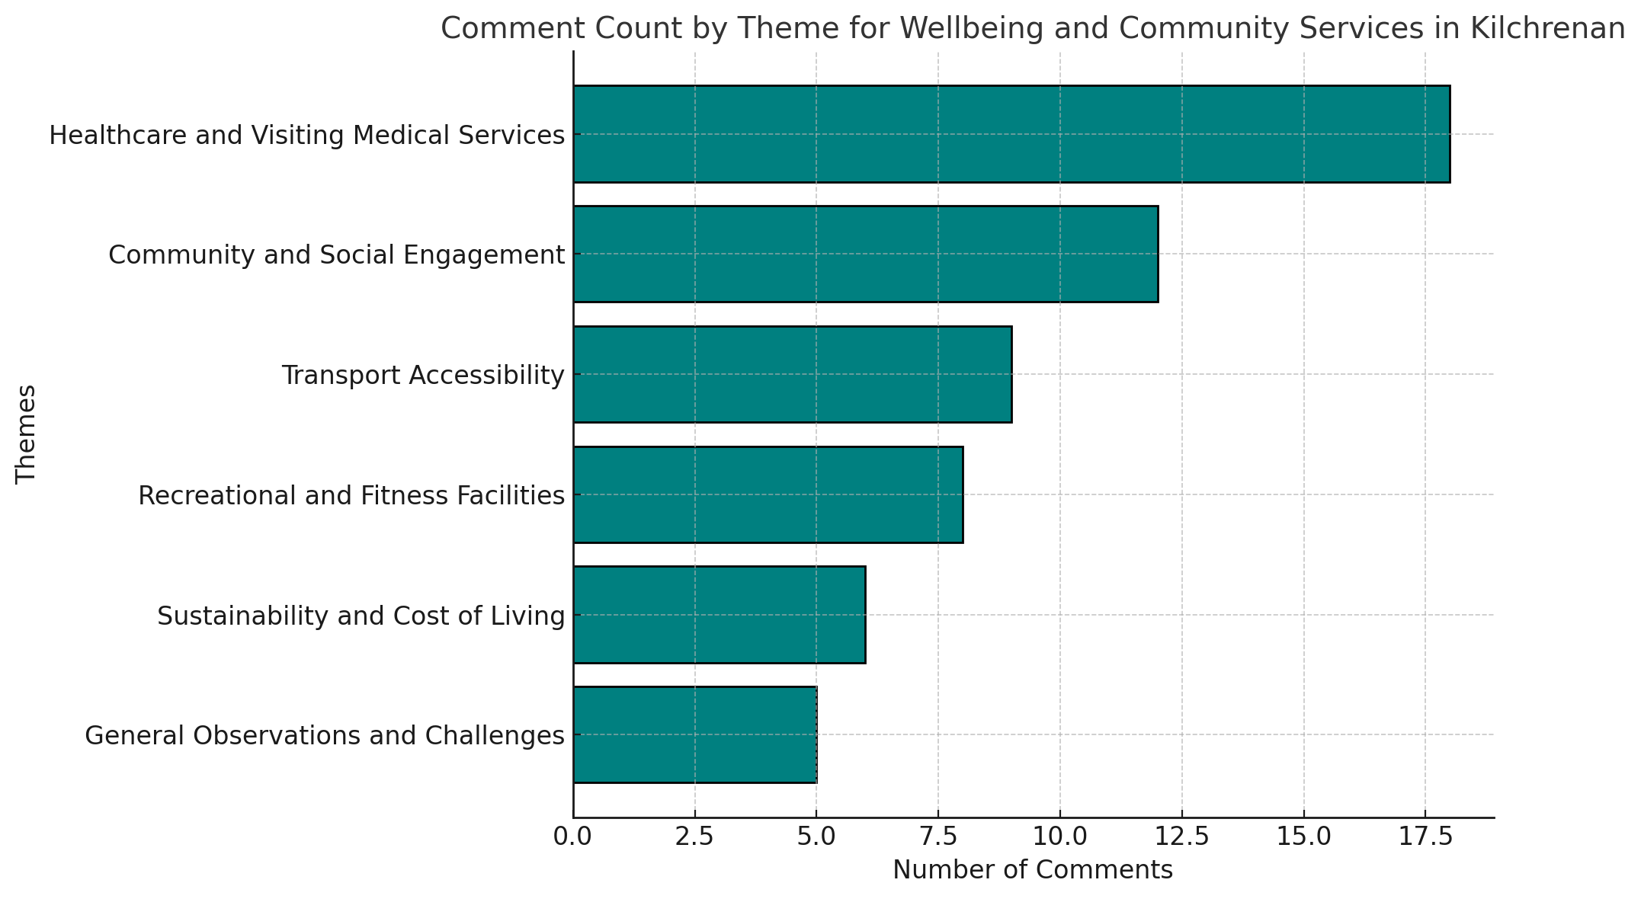

**1. Health Care & Visiting Medical Services:** Visiting GP surgeries or regular clinics at community centers; Mobile medical clinics (e.g., monthly visits); Satellite medical provisions with doctors, nurses, and specialists (e.g., podiatrists, massage therapists, physios); Increased competence of doctors; Availability of social care assistants locally. Care packages tailored for the elderly and infirm; Accommodation for care workers to serve aging populations; Expansion of “hospital at home” services.

**2. Community Engagement and Isolation Reduction:** Multi-purpose centers providing spaces for health services, nurseries, craft sessions, and social activities; Social gatherings, including lectures, movie screenings, and mindfulness workshops; Addressing isolation through friendly visits and group activities.

**3. Transport and Accessibility:** Better and more frequent bus services; Improved roads for easier connectivity to nearby towns or facilities; Introduction of community-based transport, such as a “drive you” service.

**4. Recreational and Fitness Activities:** Introduction of fitness classes (e.g., yoga, keep-fit, mobility classes); Gym facilities, swimming pool, and group cycling activities; Wildlife observation and conservation work, including gardening for food.

**5. Sustainability and Cost of Living**: Supporting local produce to reduce costs and improve sustainability; Opportunities for locals to sell goods to visitors through shops.

**6. General Observations:** Some respondents expressed satisfaction with current services or were unsure of changes needed.

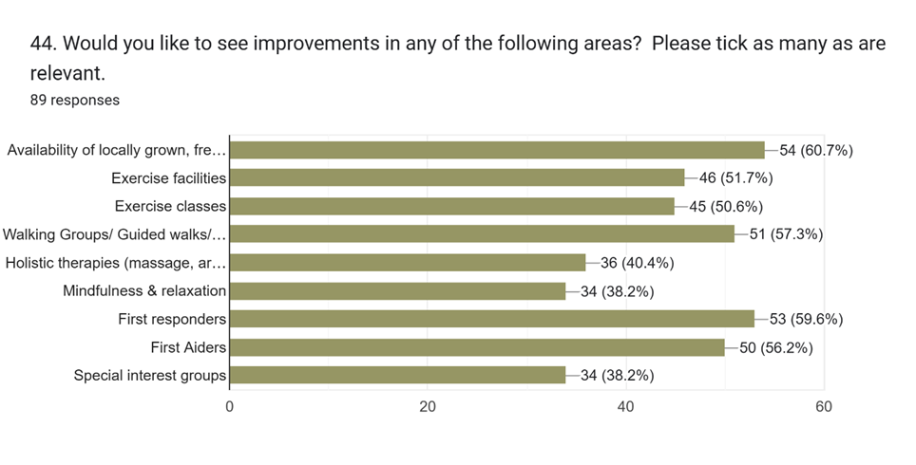

**What do you think we should do to make the area more appealing to the less able?**

**Open-ended comments/ranked by number of comments**

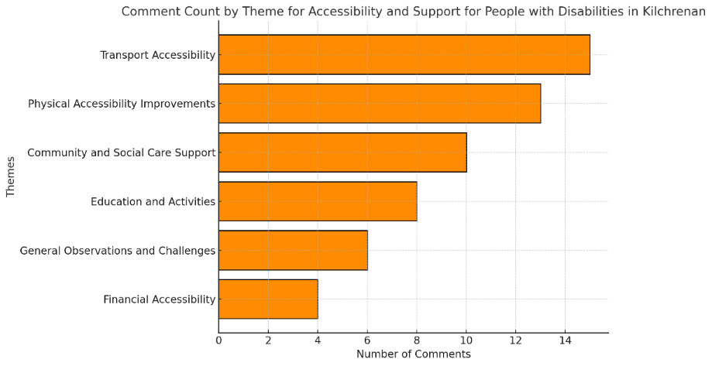

**1. Transport and Accessibility Improvements:** Suggestions for better public transport, more regular buses, and a volunteer car service for those with mobility issues; Ideas for pedestrian-friendly roads, improved bus schedules, and car-sharing initiatives.

**2. Physical Accessibility Improvements:** Improving the quality of paths and roads for wheelchairs, scooters, and assisted walkers; Adding ramps, accessible routes in forests, and access to the waterfront.

**3. Community and Social Care Support Services:** Proposals for community scooters, shared buses, and volunteer support for outings or daily needs; Better social care supports and medical services, including prescription delivery.

**4. Education & Activities:** Emphasizing better communication between neighbors and organizers to cater to accessibility needs; Offering quieter activities, dog-free times, exercise classes, disabled-friendly trails, and craft workshops.

**6. Financial Accessibility:** Suggestions to make the area more financially accessible for visitors and residents with disabilities.

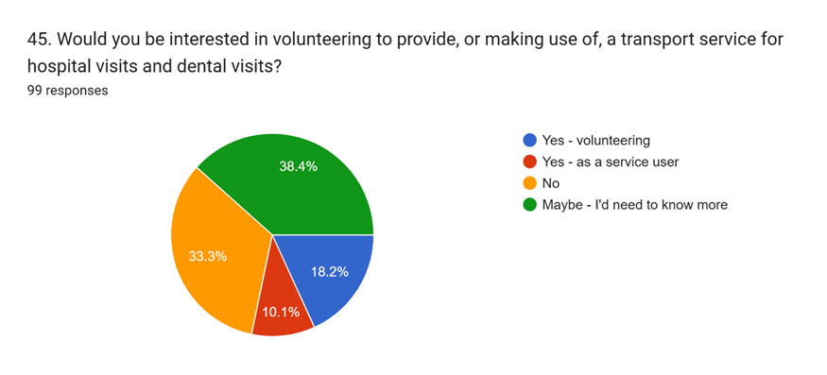

**COMMUNITY RESILIENCE**

**How could we improve the long-term potential of the community to cope in emergencies? Open-ended comments/ranked by number of comments**

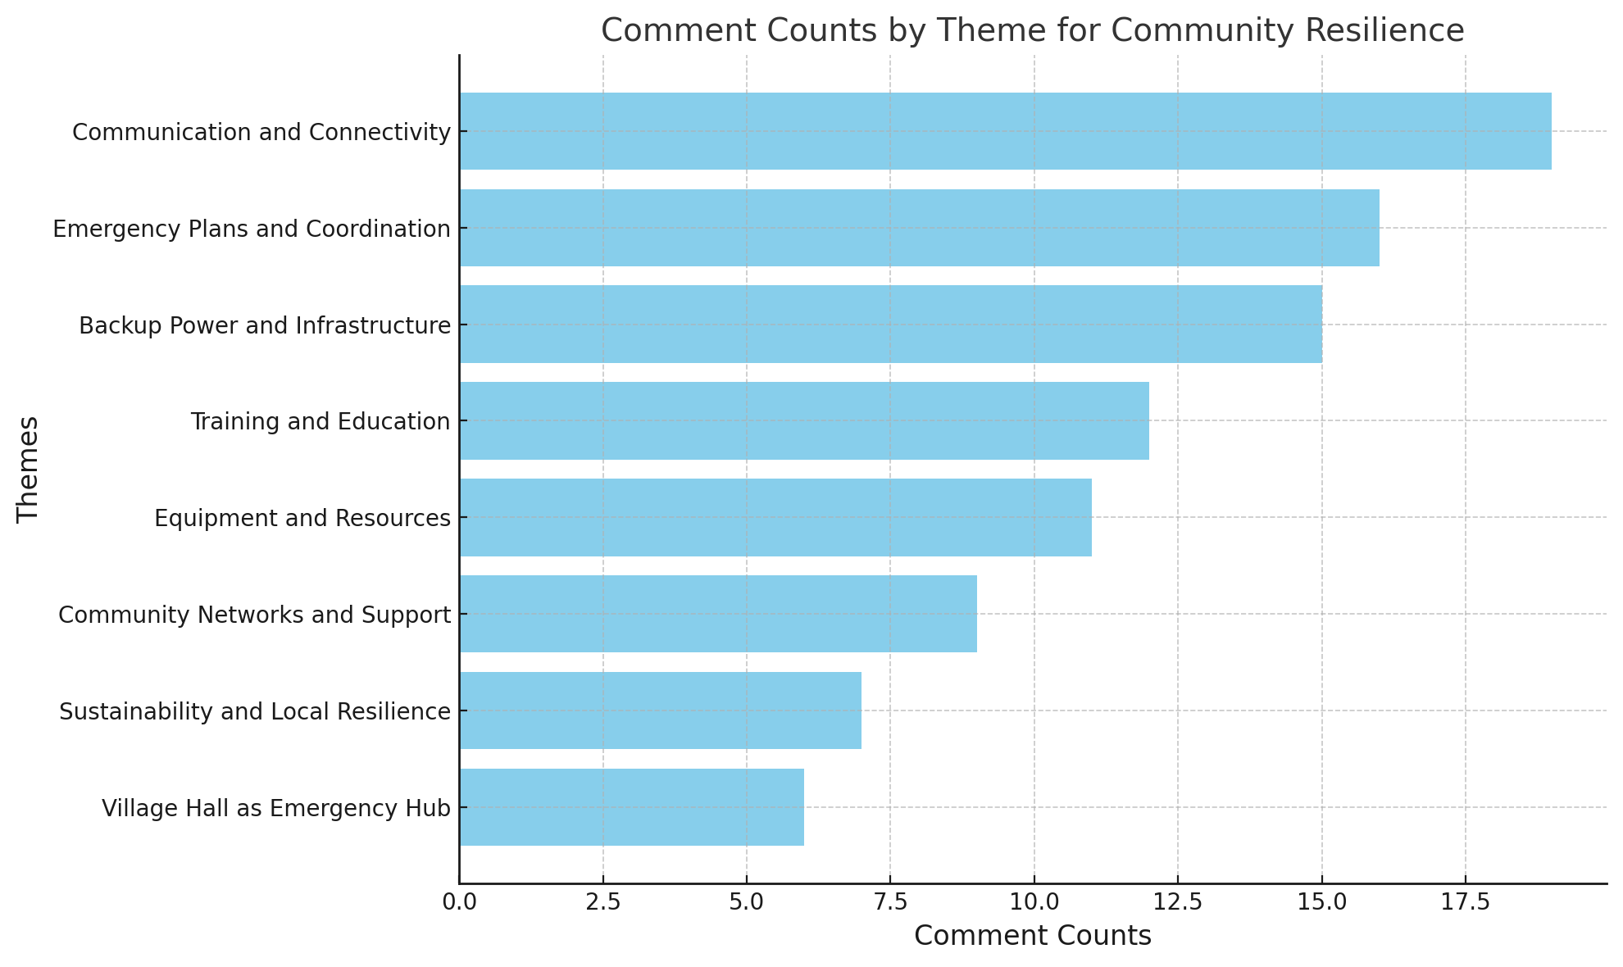

**1. Communication and Connectivity:** Improve communication during power outages (e.g., satellite internet, signal boosters, digital landline alternatives); Establish emergency communication networks (e.g., WhatsApp, social media, newsletters); Maintain a register of facilities, expertise, and resources for emergencies; Develop a power outage communications plan**.**

**2. Emergency Plans and Coordination:** Create a formal emergency response plan and ensure the community is aware of it; Appoint a coordinator for emergencies and organize community meetings; Develop action plans for specific emergencies (e.g., floods, fires, strong winds, landslides).

**3. Backup Power and Infrastructure:** Install backup generators for key facilities (e.g., village hall, medical center); Ensure reliable power for communication hubs; Encourage local power production and battery storage for sustainability.

**4. Training and Education (12 mentions):** Provide first aid, fire safety, and emergency response training; Offer basic courses on DIY, maintenance, and gardening to increase community skill levels; Host lectures and meetings to educate on emergency preparedness.

**5. Equipment and Resources:** Equip the community with essential emergency tools (e.g., defibrillators, 4x4 vehicles, boats, sandbags); Maintain shared resources like heaters, dehumidifiers, and drainage equipment; Use wood from tree maintenance to create a wood store.

**6. Community Networks and Support:** Strengthen neighbour support networks; Promote shared transport and collaborative efforts during emergencies; Improve social cohesion and involve all age groups in planning.

**7. Sustainability and Local Resilience:** Focus on local food, water, and energy production; Develop affordable housing to attract a multi-age population with diverse skills; Invest profits from community hydro projects into sustainable initiatives.

**8. Village Hall as Emergency Hub:** Use the village hall as a central hub for emergencies.

Equip the hall with necessary resources (e.g., backup power, medical supplies, communication tools).

1. **Responses to Potential Projects**

**EV Chargers**

|  |  |
| --- | --- |
| Forms response chart. Question title: 35. Should the community have EV chargers?. Number of responses: 103 responses. | Forms response chart. Question title: 36. What might the benefit of having EV chargers in the area be? Please tick all that apply.. Number of responses: 91 responses. |

**Open-ended Comments relating to EV charging**

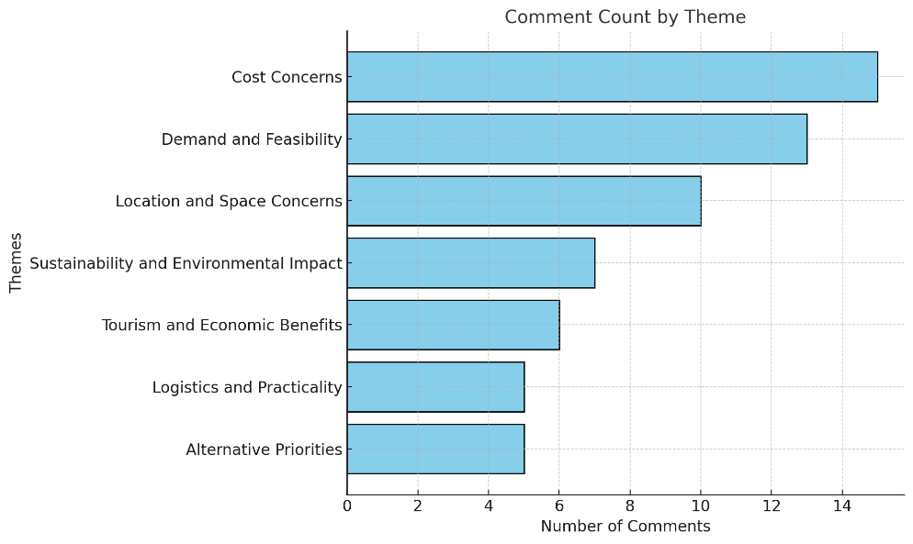

**SPORT HUB**

|  |  |
| --- | --- |
|  |  |

**FORESTRY SCHOOL & TRAINING ACADEMY**

|  |  |
| --- | --- |
| **Forms response chart. Question title: 49. Do you support your community investigating the viability of a Forest School Campus? . Number of responses: 102 responses.** |  |

**FORESTY SHED DALAVICH**

|  |  |
| --- | --- |
| Should DIG purchase the old Forestry work shed beside the green? 97 responses |  |

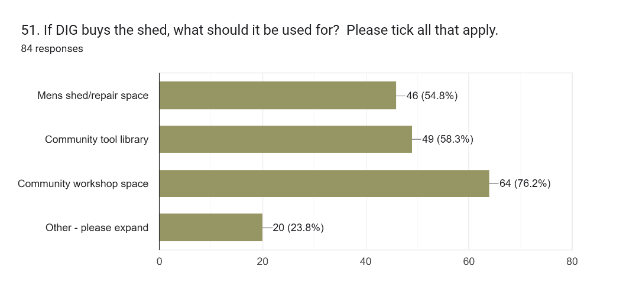

**KILCHRENAN SCHOOL**

|  |  |
| --- | --- |
| **What uses could you see for the school? Tick as many as you see fit.87 responses**   | |
|  | |
|  | |
| **Should the community buy the school? 89 responses**  **Forms response chart. Question title: 62.  If the school was used for one of your preferred options above, would you like the school to be purchased and owned by the community? . Number of responses: 89 responses.** |  |
|  |  |

**DALAVICH CHURCH**

|  |  |
| --- | --- |
| **What additional uses would you like to see for Dalavich Church? Tick as many as you see fit.77 responses** | |
| Should the community buy the church?  88 responses  **Forms response chart. Question title: 54.  If the church was used for one of your preferred options above, and met sustainability criteria (financial, fit, need etc), would you like the church to be purchased and owned by the community?  . Number of responses: 86 responses.** |  |

**KILCHRENAN CHURCH**

|  |  |
| --- | --- |
| **What additional uses would like to see for Kilchrenan Church? Tick as many as you see fit. 75 responses** | |
| **Should the community buy the church?**  **88 responses** |  |

1. **Who completed the survey** – non-identified demographics

|  |  |
| --- | --- |
| What age group are you? 109 responses | Gender. How do you identify? 109 responses |
|  |  |
| Where do you live? 109 responses | How long have you lived locally?  Forms response chart. Question title: 5. How long have you lived locally?       (This question will help us ensure we have a good cross-section of views from both residents, visitors, and property owners.)  . Number of responses: 109 responses. |
|  |  |
| Are you……109 responses | |

**6. Link to e-copy of report PLUS all comments made the survey ( all identifiable info removed)**

** OR GO TO www.akcheritables.org.uk/latest-news/**